**Reply Letter**

May. 4, 2016

Dear Editor:

Thank you for your letter dated Apr. 28, 2016 and your comments on the paper entitled “An approach to achieving optimized complex sheet inflation under constraints” for the Journal of Computers & Graphics. The paper has been carefully revised in order to accommodate the reviewer’ suggestions and comments. The grammar issues are fixed, the abstract has been changed and the equations have been revised. The following is the response/revision summary:

**For Reviewer 1:**

Thank you very much for your comments and suggestions. The grammar issues are all fixed and the abstract is changed according to your suggestions. The following is the response/revision for the issue of the equations.

***Comment 1.1****:*

*The authors have addressed all my comments from my last review satisfactorially except for about the equations in 5.1, mainly equation 6. They gave an example of how to use it with regards to figure 25d. They state that equation 6 computes a value of 4 for deltaVe as 3+1-0=4. However, computing this for Figure 25a gives you the same result4 as 2+2-0=4. DeltaVe is suppose to identify which quad set gives you the better quality, but figure 25a is clearly superior to 25d, but they both get the same deltaVe value. What am I missing? Some clarification before publication would be helpful.*

**Response**:

Thank you very much for the suggestions. The equations and example have been revised as below:

“Suppose *e* is an edge on quad set *Q*, and *Q* separates *e*’s ad- jacent hexahedra into two subsets *H*1 and *H*2, and the two new edges created by splitting *e* are *e*′ and *e*′′, then the variation between the irregular degrees of *e* and two new edges can be computed by Equ. 6. ∥*H*1∥ and ∥*H*2∥ represent the numbers of hexahedra in *H*1 and *H*2 respectively.

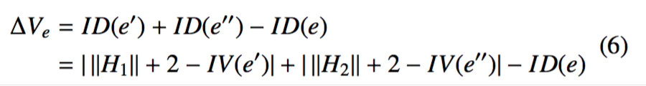

*IV*(*e*′) and *IV*(*e*′′) are usually equal to *IV*(*e*) as we try to prevent the quad set from containing mesh edges that reside on the geometric edges in Section 4.2. Therefore, Equ. 6 can be changed to Equ. 7 which removes the dependence on the information of the two new edges. This means that we can directly evaluate the quality of the quad set without conducting the real inflation.

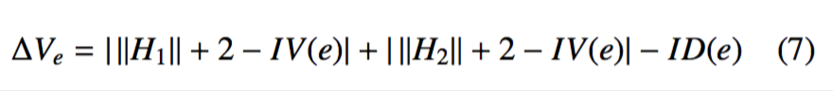

A negative ∆*Ve* means the mesh quality near *e* has been improved by the inflation, otherwise the mesh quality becomes worse. For example, in Fig. 25(d), *IV*(*e*4) = 4, so *ID*(*e*) = 0. ∥*H*1∥ = 1 and ∥*H*2∥ = 3, so ∆*Ve* = |1+2−4|+|3+2−4|−0 = 2. ∆*Ve* > 0 means that this inflation makes the mesh quality worse. ”(Sec. 5.1)

Finally, it is our pleasure to have our paper being considered to publish in Computers & Graphics. Please do not hesitate to contact us if you need further information or work.

Sincerely yours,

The authors